### Roles

Roles ensure greater security and provide users with the appropriate functionality required for their responsibilities. Access granted to each role is based on system policies as determined by the HIE.

A single user may be granted multiple roles, depending on their job requirements. For example, users with the Clinician role might only be able to view patient-related screens, while users with the Clerk role might only be able to view patient registration information.

To add a role to a user account, select an option from the **Add a role** dropdown box.

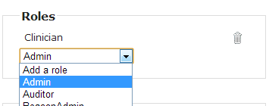

To add more than one role, wait until the *Added* confirmation message appears, then select the next role, if applicable.

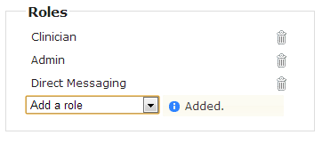

To delete a role, click on the trash can icon next to an added role. A *Deleted* confirmation message will appear briefly.

